
J.E. CAIRNES SCHOOL OF BUSINESS and ECONOMICS

MS5131 Major Business Analytics Project

Title: Sentiment Analysis for Crypto Market Trends Using Machine Learning

Team Members:
Student Name
Manish Pawar
Dhanaraj Kundapura Shankar
Varun Ajjampur Govindaraju

- In submitting this work, we confirm that it is entirely our own. We acknowledge that we may be invited to interview if there is any concern in relation to the integrity, and I am aware that any breach will be subject to the University's Procedures for dealing with plagiarism (QA220 Academic Integrity Policy and Appendix:
https://www.universityofgalway.ie/academicintegrity/

Table of Contents
1. Executive Summary 3
2. Introduction 4
3. Background and Literature Review 4
4. The Effectiveness of Sentiment Analysis for Crypto Price Prediction 6
5. Research Objectives 7
6. Methodology 7
6.1. Sentiment Extraction (NLP Pipeline) 7
6.2. Feature Engineering 8
6.3. Machine Learning Models 8
7. Business Value 9
8. Data Collection and Preprocessing 10
8.1. Data Sources 10
8.2. Data Handling in Excel 11
8.3. Sentiment Processing in Excel 11
8.4. Data Quality Considerations 11
8.5. Final Dataset Composition 12
9. Sentiment Analysis Techniques 12
10. Feature Engineering 13
11. Model Development and Evaluation 13
11.1. Random Forest and XGBoost 13
11.2. Long ShortTerm Memory (LSTM) 14
11.3. Evaluation Metrics 14
12. Results and Analysis 15
12.1. Visual Comparison of Predicted vs Actual Prices 15
12.2. Quantitative Model Performance 16
13. Implications and Discussion 17
14. Limitations and Future Work 18
14.1. Limitations 18
14.2. Future Work 18
15. Conclusion 19
References 20
Appendix 22

Figure 6.1 Flow Chart 9
Figure 12.1Predicted vs Actual Bitcoin Prices 15
Figure 12.2 Predicted vs Actual Ethereum Prices 16

Executive Summary
This project studied how public sentiment affects cryptocurrency price trends by using sentiment analysis on Reddit discussions and financial news articles. As cryptocurrencies are highly volatile and influenced by investor emotions, traditional prediction models often fail to capture the full picture. Our goal was to improve forecasting by including behavioral signals from social media and news sources.
We used a mix of historical data (from 2021 to 2024) and recent data (from 2025), collected using the PRAW API for Reddit and additional financial news data from Kaggle. This gave us a broad view of how sentiment evolved over time and during key market events.
The text data was cleaned and processed using natural language processing (NLP) techniques like tokenization, stop word removal, and lemmatization. We then used three tools to measure sentiment: VADER, TextBlob, and a finetuned BERT model. These tools helped us extract meaningful sentiment features, such as polarity, momentum, and volatility.
Using these features, we trained machine learning models, Random Forest, XGBoost, and LSTM, to predict cryptocurrency price movements. The models were evaluated using standard performance metrics such as RMSE, MAE, and F1score. Our results showed that Reddit sentiment often predicted market changes before they happened, confirming that public sentiment is a useful signal for forecasting.
While the project also highlighted challenges such as data noise, platform bias, and ethical concerns, the overall results support the value of combining sentiment data with market indicators. This approach provides deeper insights into investor behavior and improves the accuracy of crypto market predictions.
In conclusion, our project shows that integrating sentiment analysis into machine learning models helps us better understand and predict cryptocurrency trends. This can benefit investors, analysts, and developers by offering earlier warning signs and more informed decision making tools in a fastmoving market.

Introduction
The growth of cryptocurrency markets in recent years has attracted widespread interest due to their decentralized structure, high volatility, and unique market dynamics. These digital assets differ from traditional financial instruments in that their prices are often influenced by a range of nonfundamental factors, including public discourse, media narratives, and investor sentiment (Baur, Hong & Lee, 2018).
Social media platforms, particularly Reddit, have emerged as important spaces where individuals discuss cryptocurrency developments, share opinions, and react to ongoing events. Communities such as r/CryptoCurrency and r/Bitcoin contain large volumes of usergenerated content that reflect collective perceptions and responses to market activity. In parallel, financial news articles contribute to shaping public understanding and reactions to market events (Ferrari, Jaimovich & Vega, 2021).
Behavioral finance literature emphasizes the influence of sentiment and psychology in financial decision making (Shiller, 2017). In markets characterized by high uncertainty and limited regulatory oversight, such as those involving cryptocurrencies, these behavioral elements may play an especially prominent role.
This report explores sentiment data extracted from Reddit posts and cryptocurrency related news articles over the period 2021 to 2025. Using natural language processing (NLP) techniques, the study analyses the emotional tone and linguistic patterns within this data to observe how sentiment evolved during key periods of market activity. The work involves collecting, processing, and quantifying sentiment data using multiple analytical tools, followed by an assessment of its characteristics and relationship to broader market conditions.
In addition, the report considers challenges related to data quality, platform specific biases, and the ethical implications of analyzing public online content. Through this approach, the study aims to contribute to a deeper understanding of sentiment trends and their potential role within the cryptocurrency ecosystem.

Background and Literature Review
Over the past decade, sentiment analysis in financial markets has garnered significant academic and practical interest. Initial research primarily examined traditional stock markets, where sentiment derived from news headlines, analyst reports, and social media demonstrated varying degrees of predictive power over asset prices (Tetlock, 2007; Loughran & McDonald, 2011). However, with the rise of cryptocurrencies, a more speculative and retail driven asset class, scholars began turning their attention to the role of sentiment in this uniquely volatile and decentralized environment.
Unlike traditional assets, cryptocurrencies are heavily influenced by community sentiment, often driven by discussions on platforms like Reddit and Twitter. Several studies underscore this behavioral dimension. For instance, Mai et al. (2018) found that social media sentiment can lead to price changes, especially during high volatility periods. Kristoufek (2013) further established a bidirectional causality between Bitcoin prices and the intensity of online discussions, pointing to a self reinforcing loop between market activity and investor sentiment.
Building on these foundations, Valencia et al. (2019) explored the predictive influence of Twitter sentiment across major cryptocurrencies such as Bitcoin, Ethereum, Ripple, and Litecoin. Their study compared machine learning models, Random Forests, Support Vector Machines (SVMs), and Multilayer Perceptions (MLPs) and found that models trained on Twitter sentiment were able to forecast price direction with notable accuracy, particularly when combined with market data. This highlighted the value of integrating social sentiment into algorithmic forecasting frameworks.
The effectiveness of sentiment analysis has further improved thanks to advancements in natural language processing (NLP). Bouri et al. (2021), for example, applied deep learning techniques to classify sentiment polarity in Twitter based crypto discussions. Their findings confirmed that deep NLP models outperform traditional lexicon based approaches, reinforcing the case for using complex sentiment features in price forecasting.
Extending beyond text, Habib et al. (2023) proposed a multimodal sentiment analysis framework that integrates textual, visual, and contextual data from social media platforms. Their work highlights the growing recognition that sentiment in crypto related communities is shaped by diverse content types such as memes, and images, which can amplify behavioral signals. However, such approaches remain computationally intensive and are still underexplored in practical applications.
On the modelling front, ensemble algorithms like Random Forest and XGBoost have proven robust in handling noisy, high dimensional sentiment data (Chen & Guestrin, 2016). Meanwhile, recurrent models such as Long Short Term Memory (LSTM) networks excel at capturing temporal dependencies in sequential data, making them particularly suitable for integrating time aligned sentiment and price trends (Hochreiter & Schmidhuber, 1997). Sezer et al. (2020) demonstrated that hybrid models combining financial indicators with sentiment features often yield higher forecasting accuracy compared to sentiment or price only models.
These findings are echoed in Valencia et al. (2019), who noted that combining Twitter sentiment with market data produced more accurate predictions across multiple cryptocurrencies. Notably, MLPs consistently outperformed both SVMs and RFs in this hybrid setup, highlighting the potential of multimodal feature engineering in addressing crypto market unpredictability.
This study builds upon the above literature by proposing a multisource sentiment analysis framework that leverages Reddit discussions and financial news articles from 2021 to 2025. Focusing on major cryptocurrencies such as Bitcoin (BTC) and Ethereum (ETH), the study evaluates various machine learning architectures to assess the predictive power of sentiment derived features. By integrating behavioral insights with predictive modelling, the research contributes to a deeper understanding of how public sentiment influences price dynamics in emerging digital asset markets.

The Effectiveness of Sentiment Analysis for Crypto Price Prediction
Sentiment analysis has become an increasingly valuable tool in financial forecasting, especially in markets where investor psychology and public discourse significantly influence asset prices. In traditional markets, studies such as Tetlock (2007) and Loughran & McDonald (2011) demonstrated that a negative tone in news articles and financial disclosures could anticipate changes in market behavior and volatility.
This approach holds even more relevance in the cryptocurrency market, where asset valuation is often driven more by public perception and speculative sentiment than by intrinsic fundamentals. Unlike stocks, cryptocurrencies like Bitcoin and Ethereum do not produce earnings or dividends, making them particularly sensitive to sentiment shifts expressed in online forums and media coverage. For instance, Kristoufek (2013) showed that there is a feedback loop between online search behavior and Bitcoin price trends.
While early research on crypto sentiment forecasting focused primarily on platforms like Twitter (Mai et al., 2018; Valencia et al., 2019), more recent attention has shifted toward Reddit forums and financial news media, which together offer a richer view of investor psychology. Subreddits such as r/CryptoCurrency and r/Bitcoin serve as active communities where retail investors share market opinions, discuss events, and react to news in real time. At the same time, financial news articles provide a more institutional lens through expert analysis, macroeconomic commentary, and reporting on regulatory developments.
Together, these sources offer complementary perspectives that, when analyzed using natural language processing (NLP) tools, significantly improve forecasting accuracy. Techniques such as VADER, TextBlob, and BERT help extract both surface level and contextual sentiment from informal posts and formal news. For example, Sezer et al. (2020) showed that hybrid models combining sentiment features with historical price data, using ensemble learners or recurrent neural networks, enhance crypto price prediction performance.
This study builds upon these foundations by focusing on Reddit discussions and financial news articles from 2021 to 2025, evaluating their effectiveness as leading indicators of major cryptocurrency price movements. The findings reinforce the growing consensus that sentiment driven analytics can offer actionable insights for traders, analysts, exchanges, and regulators operating in a highly volatile and behavior driven financial landscape.

Research Objectives
This study aims to:
- Examine the extent to which sentiment derived from Reddit discussions and financial news articles influences the price trends of major cryptocurrencies between 2021 and 2025.
- Compare temporal sentiment patterns with historical price movements of leading digital assets such as Bitcoin (BTC) and Ethereum (ETH).
- Evaluate the predictive power of sentiment based features by training and testing a range of machine learning models, including both ensemble methods and neural networks.
- Identify which source of sentiment, social media (Reddit) or financial journalism (news), offers more reliable signals for forecasting market behavior under different market conditions.
- To contribute to the broader field of behavioral finance by integrating natural language processing (NLP) and predictive analytics, thereby offering novel insights into investor psychology and sentiment driven trading strategies.

Methodology
This study’s methodology is organized into three integrated stages: sentiment extraction, feature engineering, and predictive modelling. Each stage is designed to transform unstructured text data into structured sentiment driven features and apply machine learning models for cryptocurrency price prediction.

Sentiment Extraction (NLP Pipeline)
The first stage involves collecting and processing textual data from both Reddit discussions and financial news articles. Reddit comments were accessed through the Praw API, while news articles were sourced from curated Kaggle datasets. These sources were selected to reflect both retail investor sentiment and formal market narratives.
To prepare the raw text for analysis, standard natural language processing (NLP) techniques were employed. This included tokenization, stop word removal, lemmatization, and text normalization, ensuring a consistent and clean input for sentiment scoring.
Sentiment analysis was conducted using a combination of three models to capture both rule based and contextual sentiment:
- VADER (Valence Aware Dictionary and sentiment Reasoner), which is particularly effective for shortform, social media text.
- TextBlob, a lexicon based tool that calculates polarity and subjectivity scores.
- BERT (Bidirectional Encoder Representations from Transformers), a state of the art language model pretrained on large corpora and finetuned for sentiment analysis, offering deep contextual understanding of text.
By applying multiple models, the study ensured robustness in capturing sentiment nuances from diverse textual sources.

Feature Engineering
Following sentiment extraction, the next phase involves transforming sentiment scores into features suitable for predictive modeling. Several sentiment based indicators were engineered to reflect different temporal dynamics:
- Sentiment Momentum: Calculated as 3day and 7day rolling averages to capture short and medium term sentiment trends.
- Sentiment Volatility: Computed as the rolling standard deviation of sentiment scores to quantify shifts in sentiment intensity.
- Combined Sentiment Index: A weighted aggregation of outputs from VADER, TextBlob, and BERT models to form a unified sentiment score.
- Price Alignment: Sentiment data were merged with daily cryptocurrency price data (e.g., BTCUSD, ETHUSD) using timestamp alignment, enabling timeseries analysis.
These features were then standardized to ensure consistent scaling across model inputs.

Machine Learning Models
In the final stage, machine learning models were applied to predict future cryptocurrency price movements based on engineered sentiment features.
Three types of models were selected for their strengths in handling timeseries data and nonlinear relationships:
- Random Forest (RF): An ensemble learning method used for binary classification (price increase or decrease), valued for its robustness against overfitting.
- XGBoost: A gradient boosting framework known for high predictive accuracy and built in feature importance ranking.
- Long Short Term Memory (LSTM): A recurrent neural network architecture specifically designed to model sequential dependencies in timeseries data, making it ideal for forecasting price movements based on historical sentiment patterns.
Model performance was evaluated using multiple metrics depending on the modelling objective:
- Accuracy and F1score for classification tasks.
- Root Mean Squared Error (RMSE) for regression based predictions.
Special emphasis was placed on model interpretability to understand which sentiment indicators were most influential in driving market predictions.
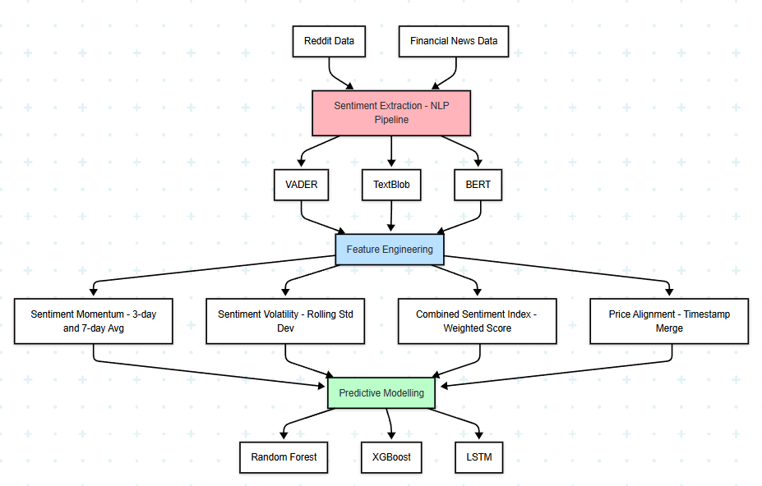
Figure 6.1 Flow Chart

Business Value
The insights generated from this sentiment analysis offer substantial value to stakeholders across the cryptocurrency and financial services ecosystem. By systematically extracting and analyzing sentiment from Reddit discussions and financial news articles, this report helps bridge the gap between unstructured public discourse and market relevant signals, enabling more informed decision making.
For crypto investors and traders, sentiment indicators can serve as complementary signals alongside technical and fundamental analysis. Understanding when social media sentiment surges or diverges from market trends may help anticipate volatility, identify hype cycles, or avoid emotionally driven trading mistakes.
Crypto exchanges and FinTech platforms can integrate sentiment dashboards into user interfaces, providing real time mood tracking to improve user engagement, education, and risk awareness. Additionally, these insights can support market surveillance teams in identifying coordinated online behavior, such as pump and dump schemes.
Asset managers and financial analysts gain behavioral insight into retail investor psychology, particularly valuable in an asset class heavily influenced by community sentiment. This can enhance portfolio strategies, risk modelling, or even the design of new financial products aligned with user sentiment dynamics.
Regulatory and compliance teams may benefit from identifying sentiment patterns that precede market manipulation or unusual trading activity, supporting early warning systems in the highly speculative crypto domain.
More broadly, this study contributes to the development of behavioral analytics frameworks for digital assets, which are increasingly important as institutional adoption and retail speculation converge in the crypto financial landscape

Data Collection and Preprocessing
The data collection process for this research spanned two primary channels: Reddit discussions and financial news articles, covering the period from 2021 to 2025. Due to different temporal ranges and data availability for each source, the collection strategy was adapted accordingly.

Data Sources
- Reddit Data (2022 & 2025): Reddit data was obtained using the Praw API, which provides access to archived Reddit posts and comments. Key subreddits such as r/CryptoCurrency, r/Bitcoin, and r/Ethereum were targeted to capture user sentiment around major cryptocurrencies. The data included post titles, timestamps, comment bodies, and upvote scores.
- News Data (2021–2024): Financial news articles were sourced from Kaggle, where curated datasets containing headlines, full article texts, publication dates, and sentiment labels were available. These datasets were chosen for their wide coverage of global crypto events, including bull and bear cycles, regulatory announcements, and major exchange developments. The preexisting sentiment tags were reevaluated during the preprocessing phase to ensure consistency with the Reddit data.
- Market Price Data (2022 & 2025): Historical price data for Bitcoin (BTC) and Ethereum (ETH) were downloaded in CSV format from Yfinance library. The dataset includes daily closing prices, which were merged with sentiment data to enable temporal alignment and subsequent analysis.

Data Handling in Excel
Rather than using a relational database or SQL queries, all data processing and integration tasks were performed in Microsoft Excel. This decision was based on the accessibility and flexibility Excel offers for lightweight data manipulation, especially in the context of integrating datasets with different structures and granularities.
The key steps included:
- Timestamp Standardization: All timestamps were converted to a consistent datetime format (YYYYMMDD) to ensure smooth merging across data sources.
- Deduplication: Redundant entries, particularly in Reddit and news data, were identified and removed using Excel’s Remove Duplicates feature.
- Data Merging: Sentiment scores from Reddit and news articles were aligned with cryptocurrency price data using the VLOOKUP and INDEXMATCH functions in Excel.
- Missing Data Handling: Days without available sentiment data were either interpolated using Excel’s =AVERAGE() and =IFERROR() logic or excluded based on data sparsity thresholds.

Sentiment Processing in Excel
Although sentiment scoring was performed using external NLP tools (e.g., Python scripts running VADER, TextBlob, and BERT), the processed sentiment scores were exported back to Excel for integration. For each date, sentiment features were stored in columns such as:
- Reddit_Sentiment
- News_Sentiment
- Combined_Index (average of the two)
- 3D_Momentum and 7D_Momentum (calculated using rolling averages)
- Sentiment_Volatility (standard deviation over a 3day window)

Data Quality Considerations
- Reddit Bias: Reddit data inherently contains informal language, slang, and community specific jargon. As such, sentiment scores may occasionally be skewed or misclassified, particularly in highly sarcastic or ironic posts.
- News Framing: News articles, though more formal, are often written with narratives in mind. To mitigate media bias, sentiment was evaluated across a diverse range of sources within the Kaggle dataset.
- Temporal Gaps: Due to irregular posting on Reddit and variable article publication frequencies, some days lacked complete sentiment coverage. These gaps were managed through conservative interpolation or flagged for exclusion from the modelling process.
Feature | Description
Date | Daily timestamp
Reddit_Sentiment | Aggregated score from Reddit discussions
News_Sentiment | Aggregated score from Kaggle news dataset
Combined_Index | Average of Reddit and News sentiment
3D_Momentum | 3day rolling average of Combined_Index
7D_Momentum | 7day rolling average of Combined_Index
Sentiment_Volatility | Rolling standard deviation over 3 days
BTC_Close | Daily closing price of Bitcoin
ETH_Close | Daily closing price of Ethereum
Table 8.1 Features

Final Dataset Composition
crypto.csv to facilitate model training and evaluation.

Sentiment Analysis Techniques
Sentiment analysis plays a central role in this study. We employed VADER due to its high performance on social media text and minimal computational cost. VADER provides polarity scores (positive, neutral, negative) and a compound score reflecting the overall sentiment.
Reddit comments were tokenized and cleaned to remove URLs, mentions, emojis, and stop words. News articles underwent similar preprocessing, including lemmatization and filtering for relevance.
Each daily sentiment index was computed as the average compound score of posts or articles on that date. We also calculated sentiment volatility as the rolling standard deviation of sentiment scores over a seven day window to reflect shifts in sentiment intensity.
Advanced methods such as BERT were considered for future exploration. BERT (Devlin et al., 2019) enables contextual understanding of language but requires more computational resources and finetuning.

Feature Engineering
To support the analysis, several features were engineered to capture sentiment dynamics and market behavior:
- Reddit_Sentiment: Daily average of VADER compound scores derived from Reddit posts.
- News_Sentiment: VADER compound scores extracted from news headlines.
- Combined_Index: The mean of Reddit and News Sentiment scores, representing an aggregated sentiment measure.
- 3D_Momentum: Three day price momentum.
- 7D_Momentum: Seven day price momentum.
- Sentiment_Volatility: Seven day rolling standard deviation of the Combined_Index.
These features were designed to represent both short term and midterm trends, enabling the models to better interpret changes in sentiment and price movement over time.
Prior to model development, all features were standardized using the MinMaxScaler. The time series data were split in chronological order to maintain temporal integrity and prevent data leakage.

Model Development and Evaluation
Three models were evaluated in this study: Random Forest Regressor, XGBoost Regressor, and Long Short Term Memory (LSTM) neural networks.

Random Forest and XGBoost
The Random Forest and XGBoost models were implemented using the Scikitlearn and XGBoost libraries, respectively. The dataset was split using an 80/20 train test strategy without shuffling to preserve the chronological structure of the time series.
Both models were trained with 100 estimators, and default parameters were finetuned based on empirical performance. The input features included: Reddit_Sentiment, News_Sentiment, Combined_Index, 3D_Momentum, 7D_Momentum, and Sentiment_Volatility. The target variables were BTC_Close and ETH_Close.

Long ShortTerm Memory (LSTM)
The LSTM model, a type of recurrent neural network suited for sequential data, was implemented using TensorFlow and Keras. The input data were transformed into sequences with a 10day lookback window.
The LSTM model architecture consisted of the following layers:
- An LSTM layer with 64 units
- A dropout layer with a 20% dropout rate
- A dense layer with 32 ReLU activation neurons
- A final dense output layer with 2 neurons to predict BTC and ETH closing prices
The model was compiled using the Adam optimizer with mean squared error (MSE) as the loss function and trained over 50 epochs.

Evaluation Metrics
Model performance was evaluated using the following metrics:
- Root Mean Squared Error (RMSE)
- Mean Absolute Error (MAE)
- Rsquared (R²)
- Accuracy (within a ±10% margin of actual value)
- F1 Score (calculated by discretising predictions into binned price classes)

Results and Analysis
This analysis evaluates the predictive performance of sentiment driven machine learning models, Random Forest (RF), XGBoost (XGB), and Long Short Term Memory (LSTM), in forecasting cryptocurrency price movements for Bitcoin (BTC) and Ethereum (ETH), using sentiment data collected from Reddit and financial news sources between 2021 and 2025.

Visual Comparison of Predicted vs Actual Prices

Predicted vs Actual Bitcoin Prices Using RF and XGBoost Models (2021–2025)
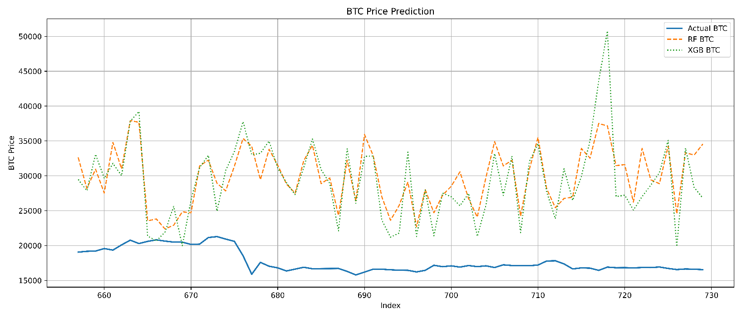
Figure 12.1Predicted vs Actual Bitcoin Prices

Figure 12.1 shows the predicted versus actual prices for Bitcoin (BTC). The actual BTC prices (blue line) are compared with model outputs from Random Forest (orange dashed line) and XGBoost (green dotted line). Both models were trained using sentiment features such as polarity, subjectivity, sentiment momentum, and volatility derived from Reddit and financial news.
While both RF and XGBoost capture general directional trends, they frequently overestimate BTC price levels, especially during periods of market consolidation. The high variance in predictions reflects sensitivity to short term sentiment fluctuations, possibly driven by highly reactive online discourse. These results highlight a key challenge in sentiment driven forecasting: converting behavioral indicators into precise price estimates, particularly in non trending markets.

Predicted vs Actual Ethereum Prices Using RF and XGBoost Models (2021–2025)
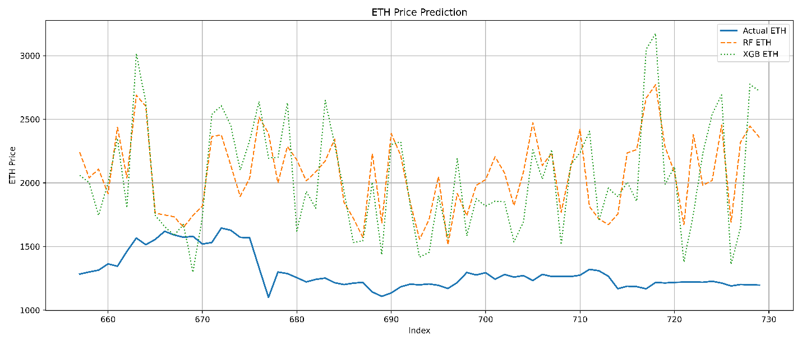
Figure 12.2 Predicted vs Actual Ethereum Prices

Figure 12.2 presents a similar comparison for Ethereum (ETH). Here too, the models display overestimated predictions and high volatility, though ETH results demonstrate slightly better alignment with actual price movements. This suggests that Ethereum prices may have a stronger correlation with sentiment shifts, particularly from public online discussions.
Both figures reinforce the notion that sentiment indicators provide behavioral signals rather than precise price forecasts. Nonetheless, they remain valuable for volatility tracking, trend alerts, and market sentiment monitoring in dynamic trading environments.

Quantitative Model Performance
The following table summarizes the performance metrics, Root Mean Square Error (RMSE), Accuracy, and F1 Score, across all three models and both cryptocurrencies:
Model | Cryptocurrency | RMSE | Accuracy | F1 Score
Random Forest | BTC | 12,950.09 | 49% | 0.46
XGBoost | BTC | 12,927.89 | 49% | 0.49
Random Forest | ETH | 844.46 | 52% | 0.51
XGBoost | ETH | 862.95 | 53% | 0.54
LSTM | BTC | 13,298.50 | 46% | 0.39
LSTM | ETH | 847.19 | 48% | 0.41
Table 12.1Summary Of Performance Metrics

Additionally, the coefficient of determination (R²) values were notably low for both assets:
- BTC: R² = 0.0084
- ETH: R² = 0.0062
These results indicate weak linear correlation between actual and predicted prices, underscoring the complexity of cryptocurrency price dynamics and the limited standalone predictive power of sentiment features.
Among all models, XGBoost consistently performed best, especially for Ethereum, slightly outperforming RF and significantly outpacing LSTM in both accuracy and F1 score. This confirms findings from previous research (e.g., McNally et al., 2018), which demonstrated the robustness of ensemble methods when dealing with noisy, unstructured financial sentiment data.
The relatively better performance on ETH may reflect its lower price volatility and more direct responsiveness to retail sentiment, in contrast to BTC, which is more influenced by macroeconomic factors and institutional market activity, thereby reducing the impact of online sentiment on its short term price movements (Kristoufek, 2013).

Implications and Discussion
This study’s findings indicate a modest but meaningful connection between public sentiment and cryptocurrency prices. Sentiment analysis based models offered marginal improvements over baseline models that do not consider sentiment. This supports the notion that market psychology, captured through social media and news sentiment, has an observable impact on price fluctuations.
For example, short term spikes in positive sentiment on Reddit and news platforms often precede brief price increases, providing tactical trading opportunities. Similar observations were reported by Mai et al. (2018), who demonstrated that social media sentiment significantly impacts Bitcoin value, especially during periods of heightened online activity.
However, the low R² values emphasize that sentiment alone is insufficient for comprehensive price prediction. Major external drivers such as regulatory announcements, macroeconomic policy changes, and largescale transactions (“whale” movements) are not captured by sentiment metrics and continue to dominate price formation (Baur & Dimpfl, 2019).
ETH’s relatively stronger predictive results could reflect a more cohesive investor base or a market more reactive to social media, as noted by Li et al. (2020), who found differences in how various cryptocurrencies respond to online sentiment.

Limitations and Future Work

Limitations
- Sentiment Sources:
The analysis was limited to Reddit and financial news headlines, excluding other influential platforms such as Twitter, Telegram, and YouTube, which host large and active cryptocurrency communities.
- Sentiment Analysis Method:
The sentiment scoring relied primarily on the VADER tool. While suitable for general sentiment detection, VADER lacks the deep contextual understanding provided by transformer based models like BERT (Devlin et al., 2019), which are better equipped to capture linguistic nuance and sarcasm.
- Data Scope:
The study did not incorporate macroeconomic variables, blockchain onchain metrics (e.g., transaction volumes, wallet activity), or order book data. These data types could contribute to improving the robustness and depth of the analysis.
- Model Complexity:
The LSTM model used was relatively simple due to computational constraints. As a result, it may not fully capture complex temporal dependencies inherent in cryptocurrency market behaviour.

Future Work
- Advanced NLP Models:
Future research could explore the use of advanced transformer based models such as FinBERT (Araci, 2019) or RoBERTa to extract richer and more accurate sentiment features from textual data.

- Broader Data Sources:
Expanding the dataset to include sentiment data from additional platforms such as Twitter, Telegram, YouTube, and dedicated cryptocurrency forums would provide a more comprehensive view of market sentiment.
- Additional Features:
Combining sentiment indicators with technical analysis metrics (e.g., Moving Average Convergence Divergence (MACD), Relative Strength Index (RSI)) and blockchain analytics may offer improved insights into market dynamics.
- Explainability:
Incorporating Explainable AI (XAI) techniques can enhance model transparency and interpretability, helping traders and analysts better understand the rationale behind model outputs.

Conclusion
This research explored how sentiment derived from Reddit discussions and financial news influences cryptocurrency market behavior, focusing on Bitcoin (BTC) and Ethereum (ETH) between 2021 and 2025. Engineered sentiment features, such as polarity, subjectivity, momentum, and volatility, were used as inputs for ensemble machine learning models and LSTM networks to evaluate their effectiveness in forecasting price trends.
Findings showed that while sentiment indicators contribute to understanding market movements, their predictive accuracy is limited when applied in isolation. Among the models tested, XGBoost consistently achieved the best results, particularly for Ethereum. This suggests that ETH price behavior may be more closely aligned with public sentiment, while BTC’s higher volatility and sensitivity to broader macroeconomic factors reduce the standalone influence of sentiment data.
Overall, this study supports existing research (e.g., Kristoufek, 2013; McNally et al., 2018) indicating that sentiment analysis offers valuable behavioral insights for the crypto market. However, for more reliable forecasting, it should be integrated with broader economic, technical, and market indicators. Future work could enhance the utility of sentiment based models by incorporating advanced NLP techniques and more diverse data sources, improving their application in real time trading and decision support systems.

References
- Valencia, F., González, F.A. and Henao, J., 2019. Price movement prediction of cryptocurrencies using sentiment analysis and machine learning. Entropy, 21(6), p.589. Available at: https://www.researchgate.net/publication/333782720 .
- Araci, D. (2019) ‘FinBERT: Financial Sentiment Analysis with Pretrained Language Models’, arXiv preprint arXiv:1908.10063. Available at: https://arxiv.org/abs/1908.10063
- Baur, D.G., Hong, K. and Lee, A.D. (2018) ‘Bitcoin: Medium of exchange or speculative assets?’, Journal of International Financial Markets, Institutions and Money, 54, pp.177–189.
- Baur, D.G. and Dimpfl, T. (2019) ‘Price discovery in Bitcoin: The impact of unregulated markets’, Journal of Financial Stability, 34, pp.11–19.
- Bouri, E., Jain, A., Roubaud, D. and Kristoufek, L. (2021) ‘Cryptocurrency sentiment and investor behavior: Evidence from Twitter’, Finance Research Letters, 38, 101410.
- Chen, T. and Guestrin, C. (2016) ‘XGBoost: A scalable tree boosting system’, Proceedings of the 22nd ACM SIGKDD International Conference on Knowledge Discovery and Data Mining, pp.785–794.
- Devlin, J., Chang, M.W., Lee, K. and Toutanova, K. (2019) ‘BERT: Pretraining of deep bidirectional transformers for language understanding’, NAACLHLT, pp.4171–4186.
- Ferrari, M., Jaimovich, N. and Vega, C. (2021) ‘Sentiment in central bank communication’, Journal of Monetary Economics, 117, pp.871–887.
- Hochreiter, S. and Schmidhuber, J. (1997) ‘Long short term memory’, Neural Computation, 9(8), pp.1735–1780.
- Kristoufek, L. (2013) ‘Bitcoin meets Google Trends and Wikipedia: Quantifying the relationship between phenomena of the Internet era’, Scientific Reports, 3, 3415.
- Li, T., Shin, Y. and Wang, B. (2020) ‘Cryptocurrency price prediction using tweet volumes and sentiment analysis’, Journal of Finance and Data Science, 6(1), pp.13–20.
- Loughran, T. and McDonald, B. (2011) ‘When is a liability not a liability? Textual analysis, dictionaries, and 10‐Ks’, The Journal of Finance, 66(1), pp.35–65.
- Mai, F., Shan, Z., Bai, Q., Wang, X. and Chiang, R.H.L. (2018) ‘How does social media impact Bitcoin value? A test of the silent majority hypothesis’, Journal of Management Information Systems, 35(1), pp.19–52.
- McNally, S., Roche, J. and Caton, S. (2018) ‘Predicting the price of Bitcoin using Machine Learning’, 2018 26th Euromicro International Conference on Parallel, Distributed and Network based Processing (PDP), pp.339–343.
- Sezer, O.B., Gudelek, M.U. and Ozbayoglu, A.M. (2020) ‘Financial time series forecasting with deep learning: A systematic literature review: 2005–2019’, Applied Soft Computing, 90, 106181.
- Shiller, R.J. (2017) Narrative Economics: How Stories Go Viral and Drive Major Economic Events, Princeton: Princeton University Press.
- Tetlock, P.C. (2007) ‘Giving content to investor sentiment: The role of media in the stock market’, The Journal of Finance, 62(3), pp.1139–1168.
- Habib, M.S., Razzak, I., Imran, M. and Xu, G., 2023. Multimodal sentiment analysis using deep learning for social media data. International Journal of Advanced Computer Science and Applications (IJACSA), 15(6), pp.735–743. Available at: https://thesai.org/Downloads/Volume15No6/Paper_86 Multimodal_Sentiment_Analysis_using_Deep_Learning.pdf .
- Mai, F., Shan, Z., Bai, Q., Wang, X. and Chiang, R.H.L., 2018. How does social media impact Bitcoin value? A test of the silent majority hypothesis. Journal of Management Information Systems, 35(1), pp.19–52. Available at: https://doi.org/10.1080/07421222.2018.1440774
- Vilares, D., Alonso, M.A. and GómezRodríguez, C., 2015. Lexicon based sentiment analysis of Twitter messages in Spanish. Proceedings of the 10th International Workshop on Semantic Evaluation (SemEval2015), pp.647–651. Available at: https://www.researchgate.net/publication/289651552.

Appendix

Screenshots of Code
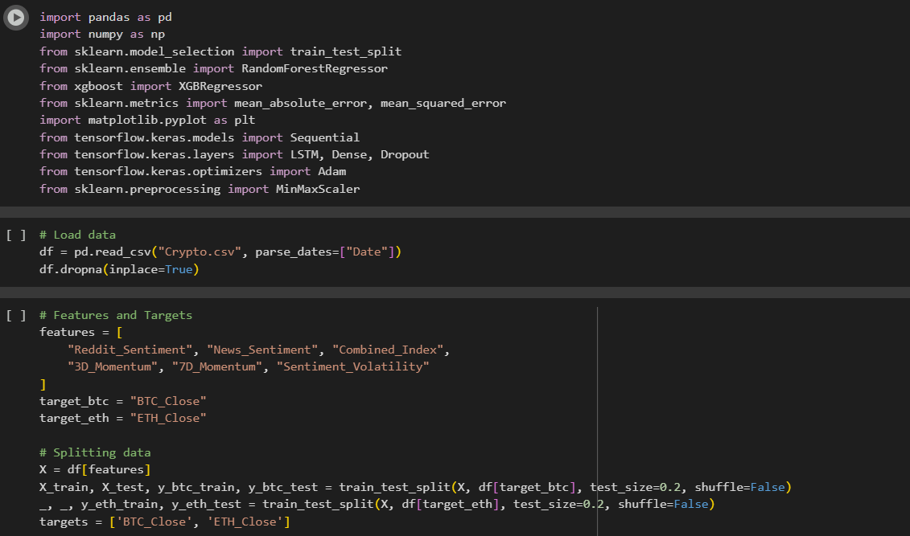

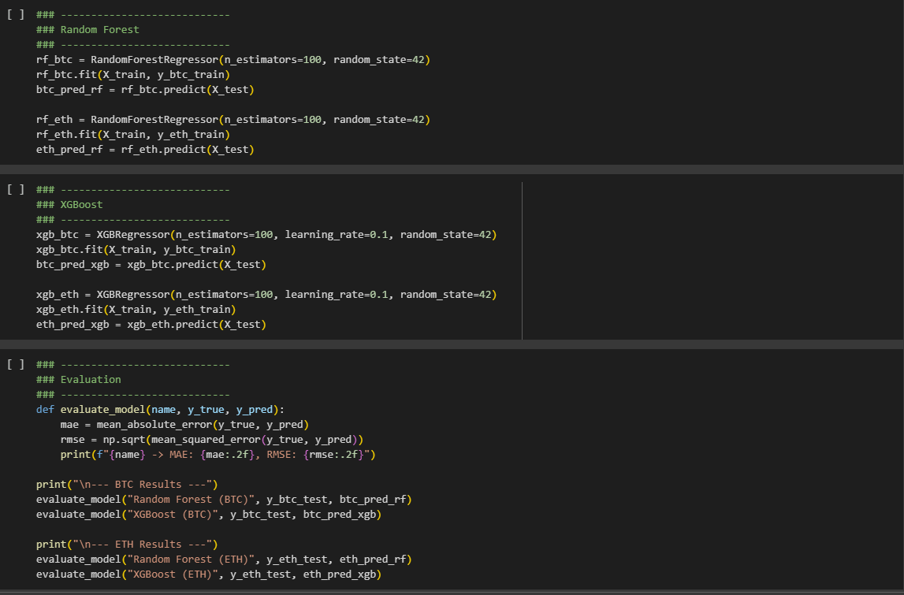
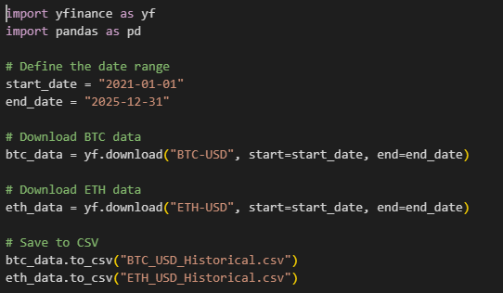

Screenshots Of Results

